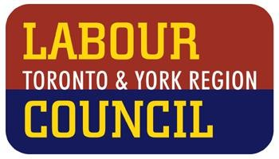LABOUR COUNCIL STANDS IN SOLIDARITY WITH WET’SUWET’EN NATION

**March 5, 2020**

In the last few weeks, the Wet’suwet’en Nation and land defenders have forced Canadians to grapple with the legacy of injustice and discrimination that has been central to this country’s development. Our governments have shamefully ignored Supreme Court rulings, the United Nations Declaration on the Rights of Indigenous Peoples, and Truth and Reconciliation Calls to Action. Police have at times seemed like a security force for corporate interests such as Coastal GasLinks.

We are learning that the hereditary leaders speak for the entire un-ceded 22,000 square kilometre Wet’suwet’en territory, while the band councils have authority within the small

reserves that were forced on First Nations peoples by our governments. It is not surprising that some band councils who have struggled to get clean water and adequate housing for their members, would acquiesce to projects which bring money and some jobs. But we have also seen courageous land defenders and supporters step up to protect rights, land and the environment.

As a labour movement, we know that work stoppages can cause inconvenience and short-term economic discomfort. But we recognize that such disruption is our best means of asserting ourselves against the strength of the employer in order to protect workers and sometimes our society as a whole. We should remember that heroes of yesterday – from Ghandi to King to the leaders of Idle No More - embraced civil disobedience as part of a struggle for equality.

Our affiliates may have diverse opinions about the Coastal GasLink project. Just as we don’t have to make the false choice between the economy and the environment, there is no need to choose between jobs and Indigenous rights. We can uphold Indigenous rights, have a good jobs economy, *and* take action on climate change. Through learning and respecting each other, we will find the leadership we need to achieve these essential objectives.

We stand with the Wet’suwet’en Nation and thank them for their leadership. We call on our governments to work towards a mutual, peaceful solution that respects the United Nations Declaration on the Rights of Indigenous Peoples. And we call on all those with power in our society to respond fully to the Truth and Reconciliation Commission’s Calls to Action.